John Grundy
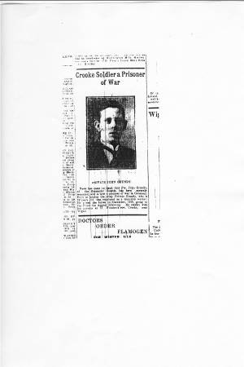
“Crooke Soldier a Prisoner of War” from the Wigan Observer, 2nd March, 1918:
“News has come to hand that Pte John Grundy, of the Grenadier Guards, has been severely wounded and is now a prisoner of war in Germany. Private Grundy, who is 19 years old, was employed as a munition worker. He joined the forces in December, 1916, going to the front the August following. He resided with his parents at 17, Woodcock-row, Crooke, near Wigan.”
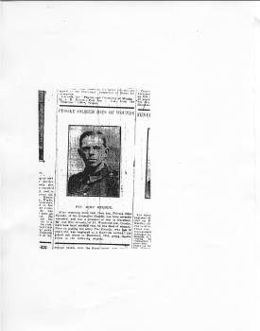
“Crooke soldier dies of wounds” from the Wigan Observer, 25th May, 1918:
“. . . Mr and Mrs Grundy have now been notified that he has died of wounds.”

John is buried at Le Cateau Military cemetery, 27 kilometres east-south-east from Cambrai.
John’s family
John Grundy, private, 28327, 4th battalion, Grenadier Guards, was born in Crooke in 1898 to James and Sarah Grundy who were boat people and lived in 17 Woodcock Row for a number of years. The parents are described as “boatman” and “boatwoman” in the 1901 census when they were living at The Locks, Scotland, Liverpool.
In 1911 the family was living at 17, Crooke and father was still a barge captain. There were two children at home, William, the eldest son, who was a mate on a canal barge, and John who was 12 years old and at school. They had two boarders, Robert Carrington, a canal barge mate, and the 75-year-old Ellen Lee.
Bernadette Green supplied the information that John’s mother had nine children, and at least four died young. Since two of the children recorded in 1901 were not on the 1911 census, this could well be true.
John’s work
John is described as a “munition worker”. He was probably employed at the Roburite and Ammonal Co., Gathurst, a mile along the canal from Crooke.
“As now made, roburite is a mixture of ammonium nitrate and chlorinated di-nitro-benzol. The nitrate of ammonia is first dried and ground, and then heated in a closed steam-jacketed vessel to a temperature of 80° C., and the melted organic compound is added, and the whole stirred until an intimate mixture is obtained. On cooling, the yellow powder is ready for use, and is stored in straight canisters or made up into cartridges. Owing to the deliquescent nature of the nitrate of ammonia, the finished explosive must be kept out of contact with the air, and for this reason the cartridges are waterproofed by dipping them in melted wax.”
“Roburite is made in Germany, at Witten, Westphalia; and also at the English Company's extensive works at Gathurst, near Wigan, which have been at work now for some eighteen years, having started in 1888. These works are of considerable extent, covering 30 acres of ground, and are equal to an output of 10 tons a day. A canal runs through the centre, separating the chemical from the explosive portions of the works, and the Lancashire and Yorkshire Railway runs up to the doors.”
From the book: “Nitro explosives, a practical treatise”, by P. Gerald Stanford, written in 1896.
The company was also responsible for the production of many thousands of tons of military ammonal for the war effort (which was made from ammonium nitrate 93.5%, aluminium powder 2.5%, trinitrotoluene 4%). Hundreds of tons were used in the mines laid at the Messines Ridge.

What happened to John?
John Grundy, private, 28327, 4th battalion, Grenadier Guards died on 15th December, 1917. He had been in France for four months.
The newspaper article identifies him as a member of the Grenadier Guards, and says that he was originally posted as a prisoner of war, but subsequently known to have died. Presumably, if he had been taken prisoner, he would have been kept by the Germans somewhere in northern France. He is buried at the Le Cateau Military Cemetery which was established as a German cemetery, and the Germans brought allied dead to it. John must have been one of those, originally buried by the Germans.
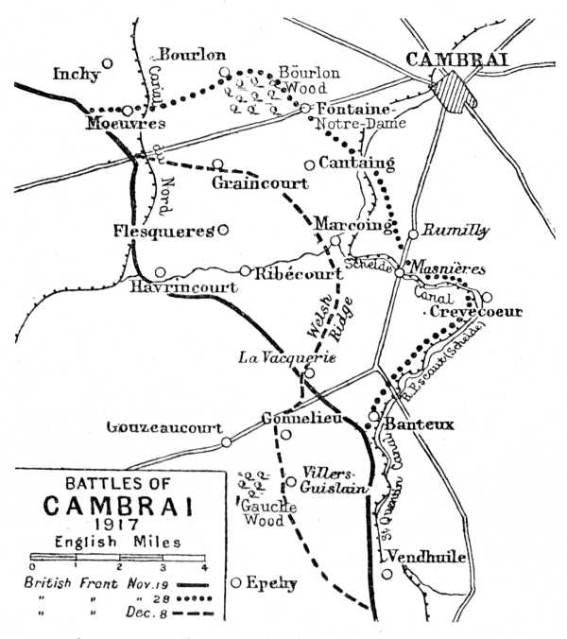
The 4th battalion of the Grenadier Guards seems to have been fighting in the area of Gouzeaucourt and Gauche Wood south-south-west of Cambrai.
“The 4th Grenadiers managed to fight their way into Gonnelieu village but they arrived just as the Germans themselves had been preparing their next assault and were thus feeding the area with reinforcements. Faced by superior numbers the Grenadiers withdrew to a covering position alongside the Welsh Guards.” . . .from an internet source, referring to events on December 1st, 1917.

